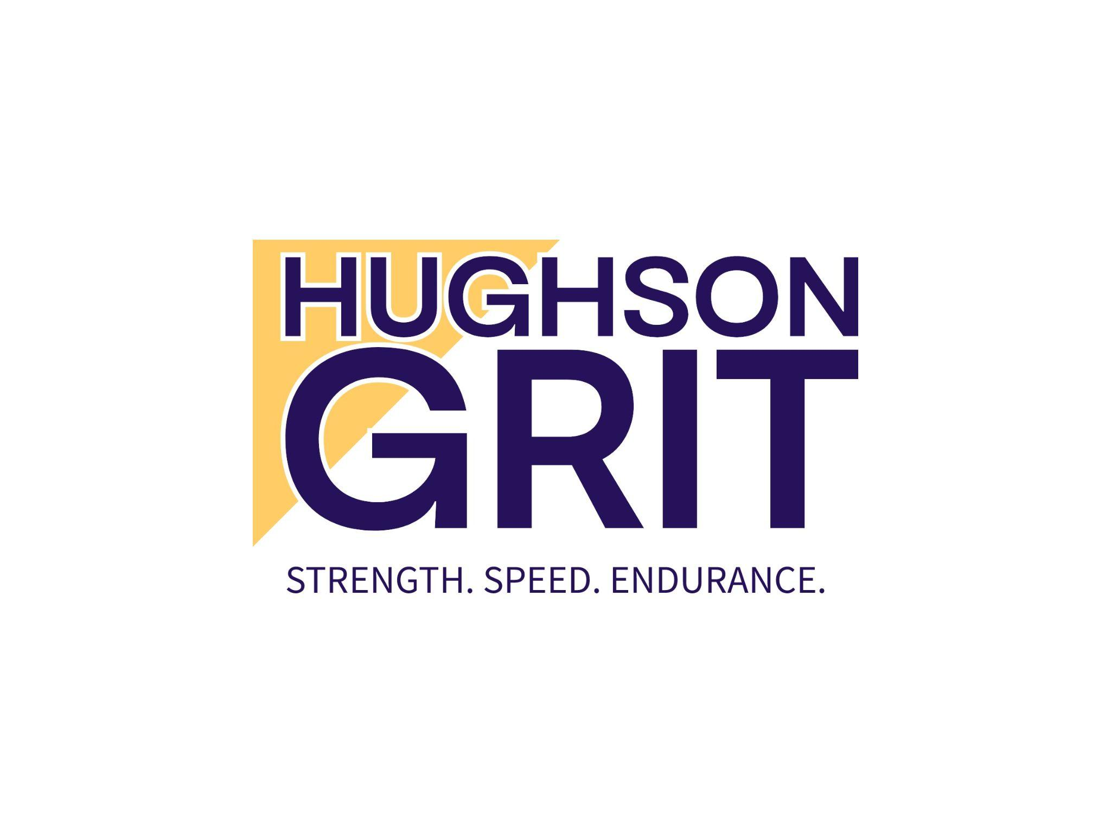

**Liability Waiver and Release**

This Liability Waiver and Release ("Waiver") is entered into on this ____ day of ______**, 2025** by and between HughsonGRIT ("Organization") and the undersigned participant ("Participant").

**1. Acknowledgment of Risks** The Participant understands that participation in fitness programs, activities, and/or use of facilities offered by HughsonGRIT (hereinafter referred to as "Activities") involves physical exertion and other activities that may be inherently risky. These activities may result in injury, including but not limited to muscle strains, fractures, sprains, cardiovascular events, and other physical or mental injuries. The Participant voluntarily assumes all risks associated with participation in the Activities.

**2. Health and Physical Condition** The Participant represents and warrants that they are in good physical condition and capable of participating in the Activities. The Participant agrees to inform the instructor or any other HughsonGRIT staff of any medical conditions, injuries, or concerns prior to participation. If the Participant is uncertain of their ability to safely participate, they should consult a healthcare professional before engaging in the Activities.

**3. Release and Indemnification** In consideration for being allowed to participate in the Activities, the Participant hereby releases, discharges, and agrees to hold harmless HughsonGRIT, its owners, employees, agents, volunteers, and all related parties from any and all claims, demands, damages, injuries, losses, or expenses (including attorney's fees) arising out of or related to the Participant's involvement in the Activities, whether caused by the negligence of HughsonGRIT or otherwise.

The Participant agrees to indemnify and defend HughsonGRIT from any such claims or actions brought against it as a result of the Participant's participation in the Activities.

**4. Emergency Medical Treatment** In the event of injury or medical emergency, the Participant consents to receive emergency medical treatment and agrees to bear any and all costs associated with such treatment.

**5. Photographic and Video Release** The Participant acknowledges and agrees that HughsonGRIT may take photographs and videos during the Activities and may use these materials for promotional, marketing, or educational purposes without compensation to the Participant.

**6. Governing Law** This Waiver shall be governed by and construed in accordance with the laws of the state of California .

**7. Entire Agreement** This Waiver constitutes the entire agreement between the Participant and HughsonGRIT with respect to the subject matter hereof. If any part of this Waiver is found to be unenforceable, the remainder shall remain in full force and effect.

**8. Age Requirement** The Participant affirms that they are at least 18 years of age. If the Participant is under the age of 18, a parent or legal guardian must sign this waiver on their behalf.

By signing below, the Participant acknowledges that they have read, understand, and agree to the terms of this Liability Waiver and Release.

**Participant Name:** _________________________  
 **Signature:** ________________________________  
 **Date:** ___________________

**If Participant is under 18, Parent/Guardian Information:**

**Parent/Guardian Name:** _____________________  
 **Signature:** ________________________________  
 **Date:** ___________________



Whether you can or can’t, you’re right!